

BAŞKENT ÜNİVERSİTESİ
ELEKTRİK-ELEKTRONİK MÜHENDİSLİĞİ BÖLÜMÜ

EEM 312 ~ SAYISAL ELEKTRONİK

LABORATUVAR UYGULAMASI

RAPOR

Deney Adı : Mantık kapısı tasarımı
Deney Numarası : Y8
Deney Tarihi : 17.05.2006

Öğrencinin Adı : Oğuz BOZKURT
Öğrencinin Numarası : 20393948

1)
A ve B girişlerine uygulanabilecek 4 farklı durum için devrenin yapısı (bacak bağlantıları) değişecektir.
→A=B=0
XOR Gate1
.MODEL MOSN NMOS LEVEL=2 LD=0.15U TOX=200.0E-10
+ NSUB=5.36726E+15 VTO=0.743469 KP=8.00059E-05 GAMMA=0.543
+ PHI=0.6 U0=655.881 UEXP=0.157282 UCRIT=31443.8
+ DELTA=2.39824 VMAX=55260.9 XJ=0.25U LAMBDA=0.0367072
+ NFS=1E+12 NEFF=1.001 NSS=1E+11 TPG=1.0 RSH=70.00
+ CGDO=4.3E-10 CGSO=4.3E-10 CJ=0.0003 MJ=0.6585
+ CJSW=8.0E-10 MJSW=0.2402 PB=0.58

.MODEL MOSP PMOS LEVEL=2 LD=0.15U TOX=200.0E-10
+ NSUB=4.3318E+15 VTO=-0.738861 KP=2.70E-05 GAMMA=0.58
+ PHI=0.6 U0=261.977 UEXP=0.323932 UCRIT=65719.8
+ DELTA=1.79192 VMAX=25694 XJ=0.25U LAMBDA=0.0612279
+ NFS=1E+12 NEFF=1.001 NSS=1E+11 TPG=-1.0 RSH=120.6
+ CGDO=4.3E-10 CGSO=4.3E-10 CJ=0.0005 MJ=0.5052
+ CJSW=1.349E-10 MJSW=0.2417 PB=0.64

M1 5 1 4 4 MOSP W=5.4u L=1.2u
M2 1 2 3 4 MOSP W=5.4u L=1.2u
M3 2 1 3 4 MOSP W=5.4u L=1.2u
M4 5 1 0 0 MOSN W=1.8u L=1.2u
M5 3 5 2 0 MOSN W=1.8u L=1.2u
M6 5 2 3 0 MOSN W=1.8u L=1.2u

vdd 4 0 5V
vin 1 0 0V
vin2 2 0 0V

.control
tran 0.1n 1u
plot v(3)
.endc
.end

→ A=0 B=1
XOR Gate2
.MODEL MOSN NMOS LEVEL=2 LD=0.15U TOX=200.0E-10
+ NSUB=5.36726E+15 VTO=0.743469 KP=8.00059E-05 GAMMA=0.543
+ PHI=0.6 U0=655.881 UEXP=0.157282 UCRIT=31443.8
+ DELTA=2.39824 VMAX=55260.9 XJ=0.25U LAMBDA=0.0367072
+ NFS=1E+12 NEFF=1.001 NSS=1E+11 TPG=1.0 RSH=70.00
+ CGDO=4.3E-10 CGSO=4.3E-10 CJ=0.0003 MJ=0.6585
+ CJSW=8.0E-10 MJSW=0.2402 PB=0.58

.MODEL MOSP PMOS LEVEL=2 LD=0.15U TOX=200.0E-10
+ NSUB=4.3318E+15 VTO=-0.738861 KP=2.70E-05 GAMMA=0.58
+ PHI=0.6 U0=261.977 UEXP=0.323932 UCRIT=65719.8
+ DELTA=1.79192 VMAX=25694 XJ=0.25U LAMBDA=0.0612279
+ NFS=1E+12 NEFF=1.001 NSS=1E+11 TPG=-1.0 RSH=120.6
+ CGDO=4.3E-10 CGSO=4.3E-10 CJ=0.0005 MJ=0.5052
+ CJSW=1.349E-10 MJSW=0.2417 PB=0.64

M1 5 1 4 4 MOSP W=5.4u L=1.2u
M2 1 2 3 4 MOSP W=5.4u L=1.2u
M3 3 1 2 4 MOSP W=5.4u L=1.2u
M4 5 1 0 0 MOSN W=1.8u L=1.2u
M5 2 5 3 0 MOSN W=1.8u L=1.2u
M6 5 2 3 0 MOSN W=1.8u L=1.2u

vdd 4 0 5V
vin 1 0 0V
vin2 2 0 5V

.control
tran 0.1n 1u
plot v(3)
.endc
.end

→A=1 B=0
XOR Gate3
.MODEL MOSN NMOS LEVEL=2 LD=0.15U TOX=200.0E-10
+ NSUB=5.36726E+15 VTO=0.743469 KP=8.00059E-05 GAMMA=0.543
+ PHI=0.6 U0=655.881 UEXP=0.157282 UCRIT=31443.8
+ DELTA=2.39824 VMAX=55260.9 XJ=0.25U LAMBDA=0.0367072
+ NFS=1E+12 NEFF=1.001 NSS=1E+11 TPG=1.0 RSH=70.00
+ CGDO=4.3E-10 CGSO=4.3E-10 CJ=0.0003 MJ=0.6585
+ CJSW=8.0E-10 MJSW=0.2402 PB=0.58

.MODEL MOSP PMOS LEVEL=2 LD=0.15U TOX=200.0E-10
+ NSUB=4.3318E+15 VTO=-0.738861 KP=2.70E-05 GAMMA=0.58
+ PHI=0.6 U0=261.977 UEXP=0.323932 UCRIT=65719.8
+ DELTA=1.79192 VMAX=25694 XJ=0.25U LAMBDA=0.0612279
+ NFS=1E+12 NEFF=1.001 NSS=1E+11 TPG=-1.0 RSH=120.6
+ CGDO=4.3E-10 CGSO=4.3E-10 CJ=0.0005 MJ=0.5052
+ CJSW=1.349E-10 MJSW=0.2417 PB=0.64

M1 5 1 4 4 MOSP W=5.4u L=1.2u
M2 3 2 1 4 MOSP W=5.4u L=1.2u
M3 2 1 3 4 MOSP W=5.4u L=1.2u
M4 5 1 0 0 MOSN W=1.8u L=1.2u
M5 3 5 2 0 MOSN W=1.8u L=1.2u
M6 3 2 5 0 MOSN W=1.8u L=1.2u

vdd 4 0 5V
vin 1 0 5V
vin2 2 0 0V

.control
tran 0.1n 1u
plot v(3)
.endc
.end

→A=B=1
XOR Gate4
.MODEL MOSN NMOS LEVEL=2 LD=0.15U TOX=200.0E-10
+ NSUB=5.36726E+15 VTO=0.743469 KP=8.00059E-05 GAMMA=0.543
+ PHI=0.6 U0=655.881 UEXP=0.157282 UCRIT=31443.8
+ DELTA=2.39824 VMAX=55260.9 XJ=0.25U LAMBDA=0.0367072
+ NFS=1E+12 NEFF=1.001 NSS=1E+11 TPG=1.0 RSH=70.00
+ CGDO=4.3E-10 CGSO=4.3E-10 CJ=0.0003 MJ=0.6585
+ CJSW=8.0E-10 MJSW=0.2402 PB=0.58

.MODEL MOSP PMOS LEVEL=2 LD=0.15U TOX=200.0E-10
+ NSUB=4.3318E+15 VTO=-0.738861 KP=2.70E-05 GAMMA=0.58
+ PHI=0.6 U0=261.977 UEXP=0.323932 UCRIT=65719.8
+ DELTA=1.79192 VMAX=25694 XJ=0.25U LAMBDA=0.0612279
+ NFS=1E+12 NEFF=1.001 NSS=1E+11 TPG=-1.0 RSH=120.6
+ CGDO=4.3E-10 CGSO=4.3E-10 CJ=0.0005 MJ=0.5052
+ CJSW=1.349E-10 MJSW=0.2417 PB=0.64

M1 5 1 4 4 MOSP W=5.4u L=1.2u
M2 3 2 1 4 MOSP W=5.4u L=1.2u
M3 3 1 2 4 MOSP W=5.4u L=1.2u
M4 5 1 0 0 MOSN W=1.8u L=1.2u
M5 2 5 3 0 MOSN W=1.8u L=1.2u
M6 3 2 5 0 MOSN W=1.8u L=1.2u

vdd 4 0 5V
vin 1 0 5V
vin2 2 0 5V

.control
tran 0.1n 1u
plot v(3)
.endc
.end

2)
NAND Gate
.MODEL MOSN NMOS LEVEL=2 LD=0.15U TOX=200.0E-10
+ NSUB=5.36726E+15 VTO=0.743469 KP=8.00059E-05 GAMMA=0.543
+ PHI=0.6 U0=655.881 UEXP=0.157282 UCRIT=31443.8
+ DELTA=2.39824 VMAX=55260.9 XJ=0.25U LAMBDA=0.0367072
+ NFS=1E+12 NEFF=1.001 NSS=1E+11 TPG=1.0 RSH=70.00
+ CGDO=4.3E-10 CGSO=4.3E-10 CJ=0.0003 MJ=0.6585
+ CJSW=8.0E-10 MJSW=0.2402 PB=0.58

.MODEL MOSP PMOS LEVEL=2 LD=0.15U TOX=200.0E-10
+ NSUB=4.3318E+15 VTO=-0.738861 KP=2.70E-05 GAMMA=0.58
+ PHI=0.6 U0=261.977 UEXP=0.323932 UCRIT=65719.8
+ DELTA=1.79192 VMAX=25694 XJ=0.25U LAMBDA=0.0612279
+ NFS=1E+12 NEFF=1.001 NSS=1E+11 TPG=-1.0 RSH=120.6
+ CGDO=4.3E-10 CGSO=4.3E-10 CJ=0.0005 MJ=0.5052
+ CJSW=1.349E-10 MJSW=0.2417 PB=0.64

M1 3 1 4 4 MOSP W=5.4u L=1.2u
M2 3 2 4 4 MOSP W=5.4u L=1.2u
M3 3 1 5 5 MOSN W=3.6u L=1.2u
M6 5 2 0 0 MOSN W=3.6u L=1.2u

vdd 4 0 5V
Vin1 1 0 pulse(5V 0V 0 10ns 10ns 100ns 200ns)
Vin2 2 0 pulse(5V 0V 0 10ns 10ns 200ns 400ns)

.control
tran 0.1n 800n
plot v(3)
.endc
.end

3)
NOR Gate
.MODEL MOSN NMOS LEVEL=2 LD=0.15U TOX=200.0E-10
+ NSUB=5.36726E+15 VTO=0.743469 KP=8.00059E-05 GAMMA=0.543
+ PHI=0.6 U0=655.881 UEXP=0.157282 UCRIT=31443.8
+ DELTA=2.39824 VMAX=55260.9 XJ=0.25U LAMBDA=0.0367072
+ NFS=1E+12 NEFF=1.001 NSS=1E+11 TPG=1.0 RSH=70.00
+ CGDO=4.3E-10 CGSO=4.3E-10 CJ=0.0003 MJ=0.6585
+ CJSW=8.0E-10 MJSW=0.2402 PB=0.58

.MODEL MOSP PMOS LEVEL=2 LD=0.15U TOX=200.0E-10
+ NSUB=4.3318E+15 VTO=-0.738861 KP=2.70E-05 GAMMA=0.58
+ PHI=0.6 U0=261.977 UEXP=0.323932 UCRIT=65719.8
+ DELTA=1.79192 VMAX=25694 XJ=0.25U LAMBDA=0.0612279
+ NFS=1E+12 NEFF=1.001 NSS=1E+11 TPG=-1.0 RSH=120.6
+ CGDO=4.3E-10 CGSO=4.3E-10 CJ=0.0005 MJ=0.5052
+ CJSW=1.349E-10 MJSW=0.2417 PB=0.64

M1 5 1 4 4 MOSP W=10.8u L=1.2u
M2 3 2 5 5 MOSP W=10.8u L=1.2u
M3 3 1 0 0 MOSN W=1.8u L=1.2u
M4 3 2 0 0 MOSN W=1.8u L=1.2u

vdd 4 0 5V
Vin1 1 0 pulse(5V 0V 0 10ns 10ns 200ns 400ns)
Vin2 2 0 pulse(5V 0V 0 10ns 10ns 200ns 400ns)

.control
tran 0.1n 800n
plot v(3)
.endc
.end

4)
WinSpice benzetim sonuçları

➔XOR Gate
→A=B=0
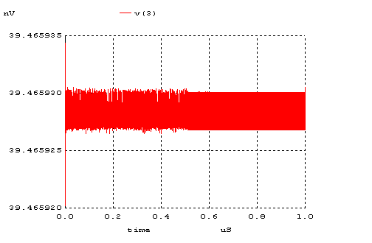

→ A=0 B=1
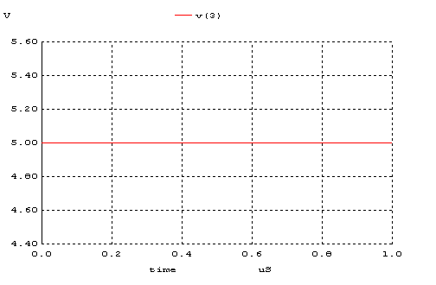

→ A=1 B=0

→ A=B=1
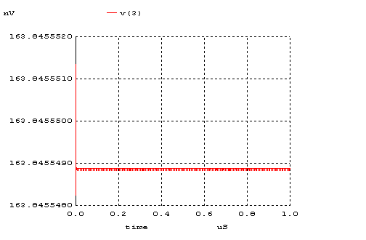

➔NAND Gate
A ve B girişleri doğruluk tablosunu sağlayacak frekanslarda devreye girilmişlerdir.

Giriş

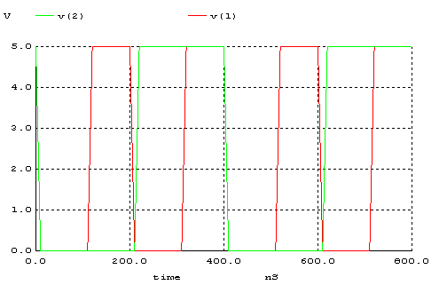
Çıkış
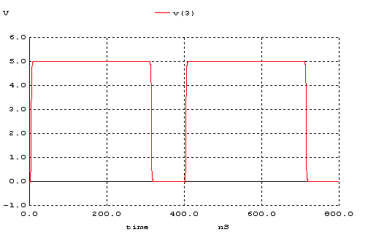

➔NOR Gate
A ve B girişleri doğruluk tablosunu sağlayacak frekanslarda devreye girilmişlerdir.

Giriş

Çıkış
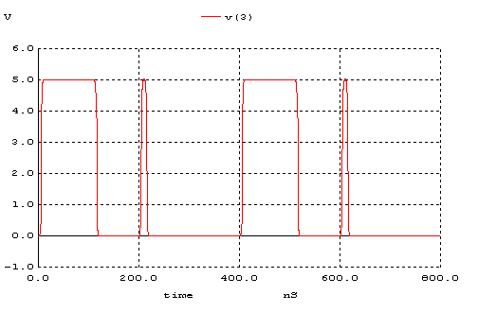

5)
NAND geçiti için en kötü gecikme A=1 B=1→0 durumunda oluşmaktadır.
Gecikme=1.135ns

NOR geçiti için en kötü gecikme A=0→1 B=0 durumunda oluşmaktadır.
Gecikme=1.623ns

